

# CLOUD COMPUTING LAB

**BSE ( V-B )**

Submitted By:

Musfira Farooq

Roll No:

2023-BSE-045

Submitted To:

Sir Muhammad Shoaib

**LAB 05**

### **Installing, Managing Packages, GUI, and Tools in Ubuntu**

**Task 1**

Java Suggestion Message

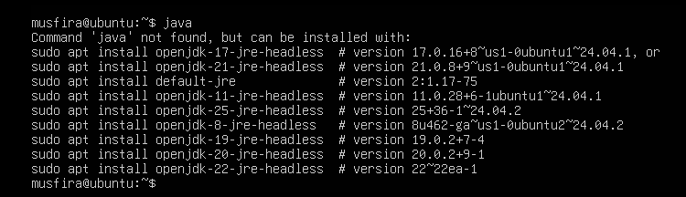

Installing Java using apt

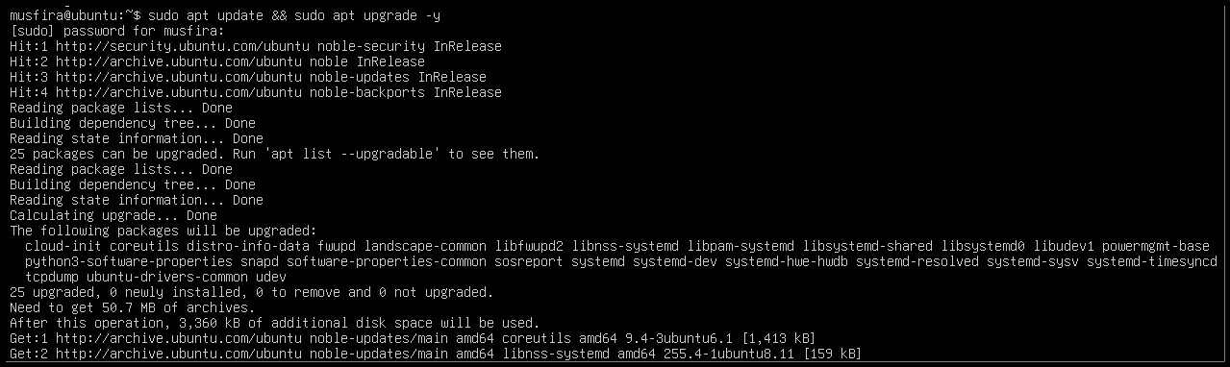

Checking Java Version

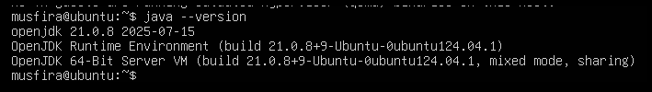

Removing Java Package

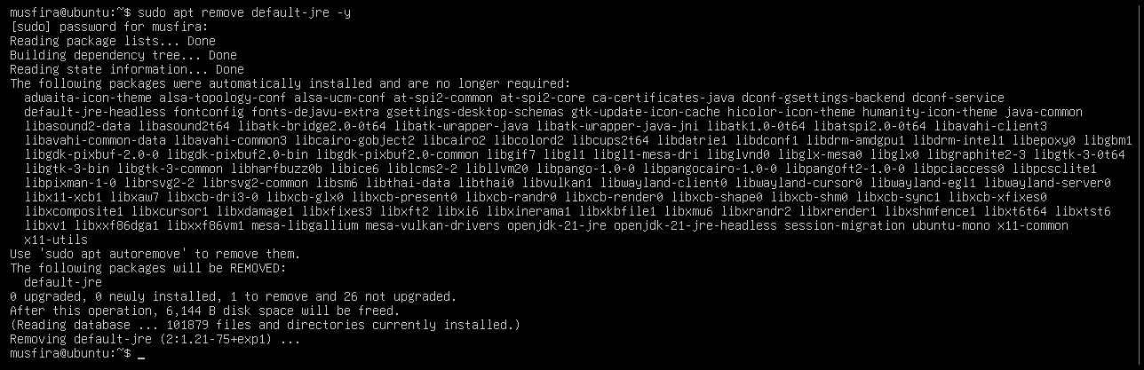

Java Not Found After Removal



Clearing Shell Cache (hash -r)

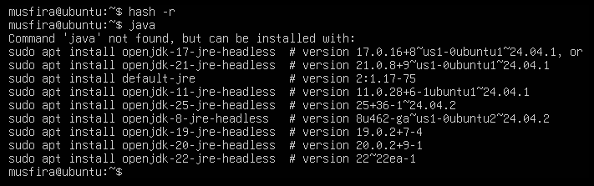

**Task 2**

Installing Java with apt-get

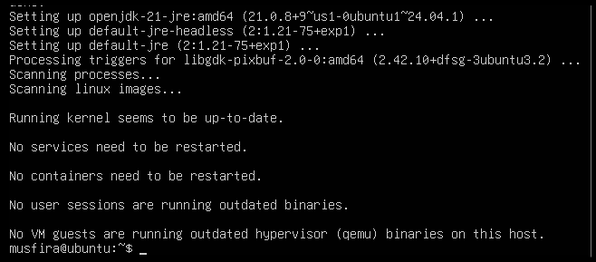

Verifying Java Version

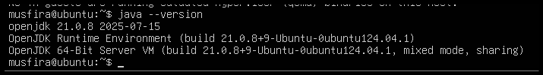

Removing Java using apt-get

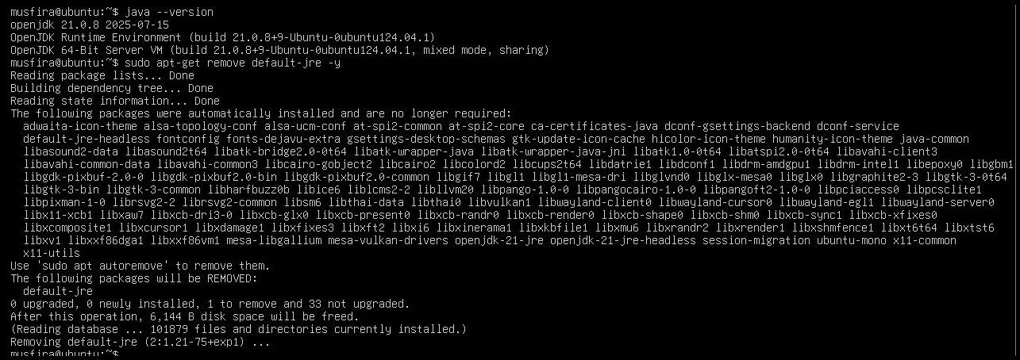

Verifying Java Removed

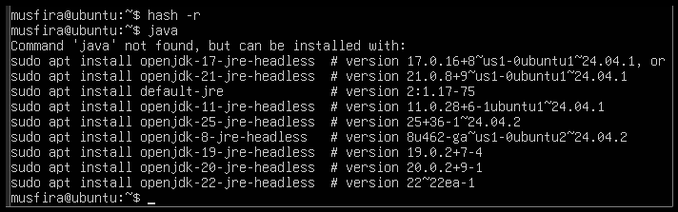

**Task 3**

Running apt update

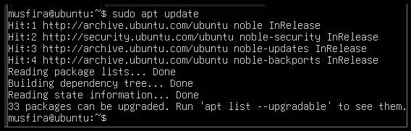

Running apt upgrade

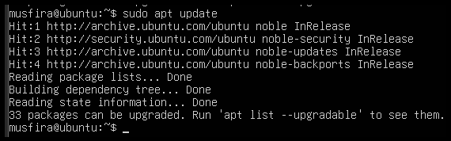

Written Explanation File

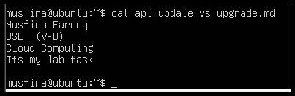

**Task 4**

Installing VS Code using Snap

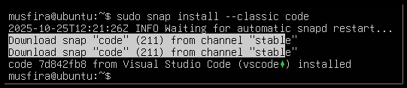

Listing Installed Snap Packages

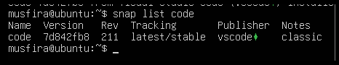

Checking VS Code Version

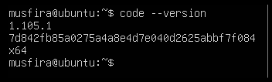

Snap Binary Location for Code

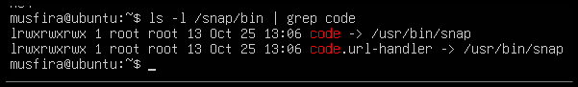

**Task 5**

Updating Packages



Installing XFCE4 Desktop Environment

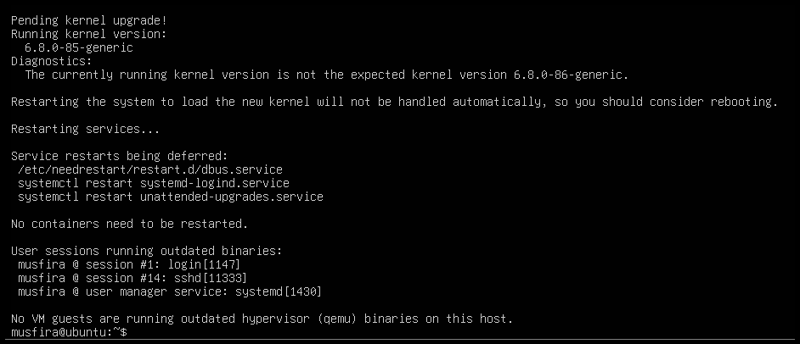

Enabling XRDP Service

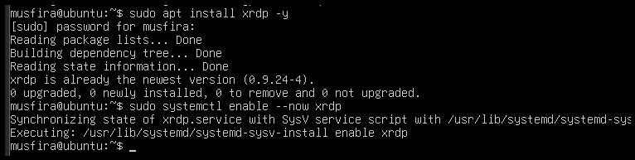

Checking XRDP Status

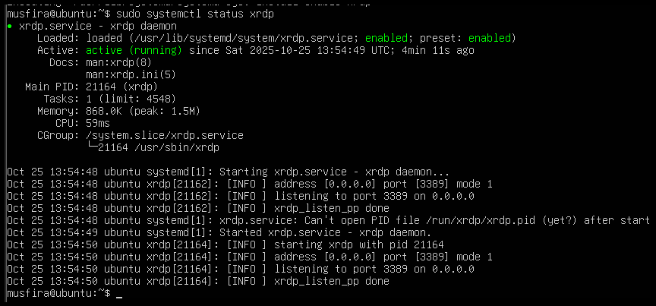

Configuring .xsession for XFCE



Remote Desktop Connection Established

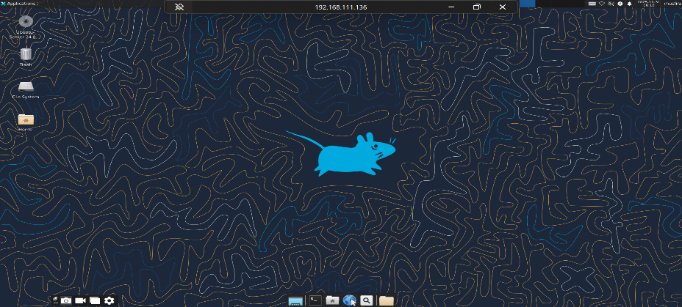

Launching VS Code in GUI

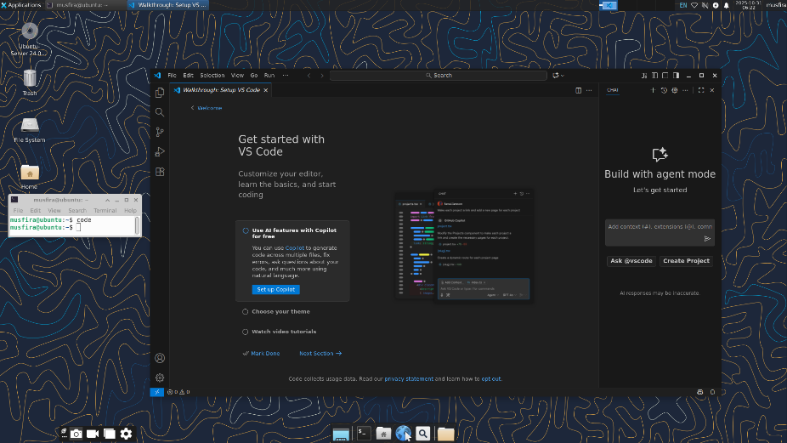

**Task 6**

Installing LightDM and Greeter

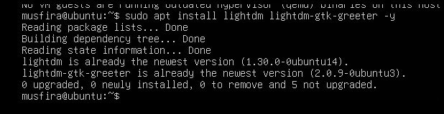

Configuring LightDM for XFCE

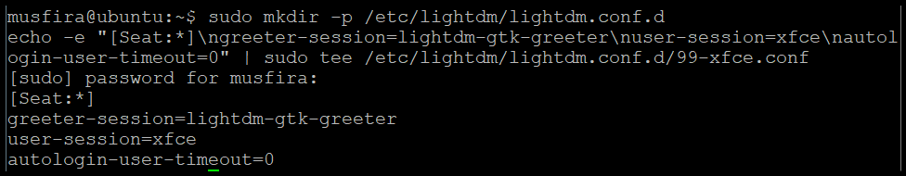

Cleaning Session Files

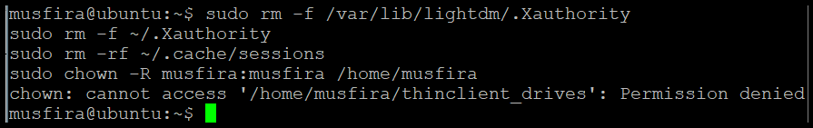

Restarting LightDM Service



Enabling GUI on Boot

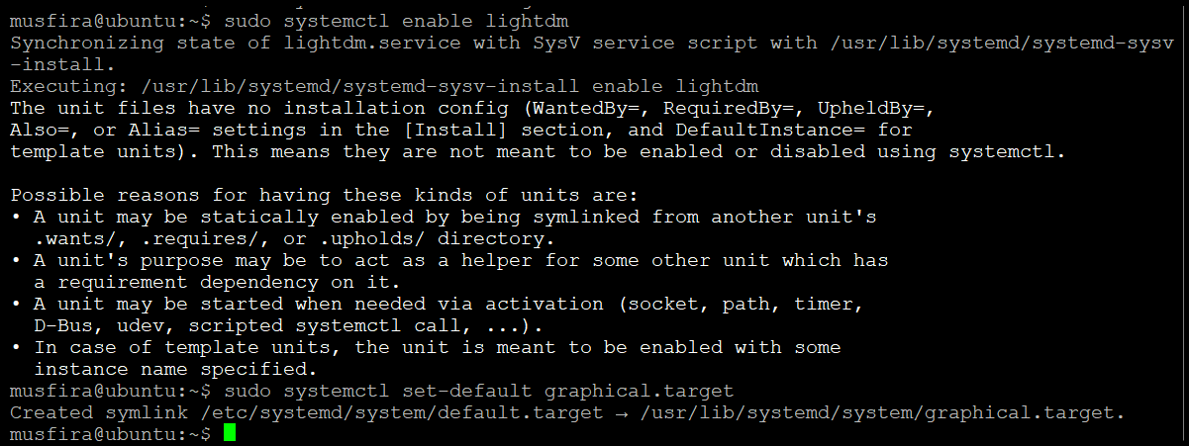

GUI Login After Reboot

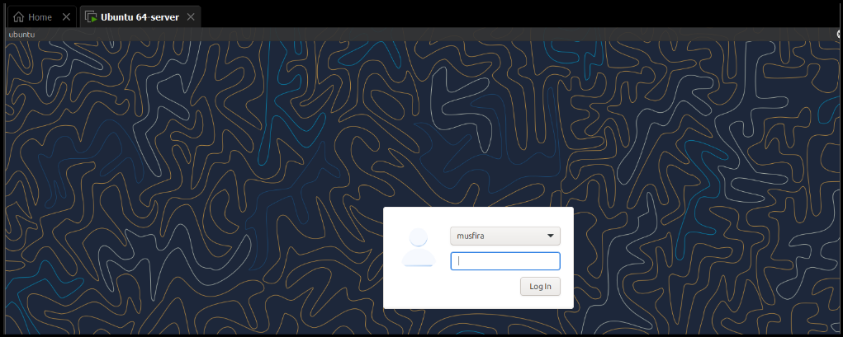

Disabling GUI on Boot

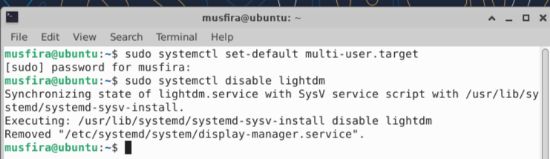

CLI Mode After Reboot

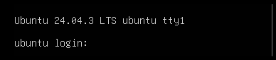

Starting GUI Manually

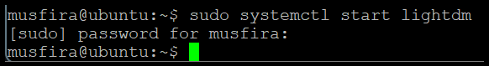

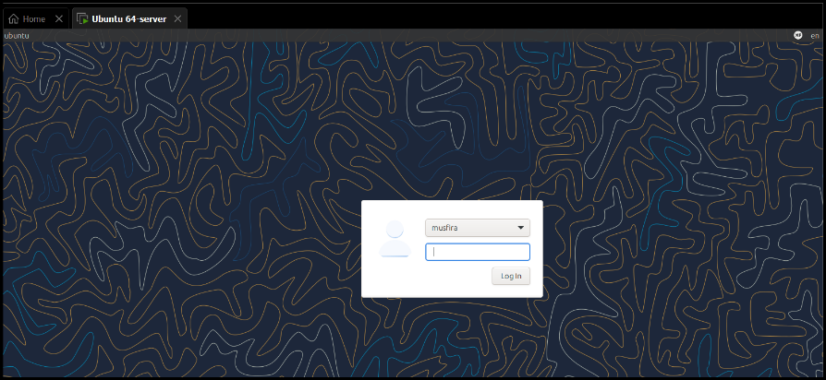

Stopping GUI Manually



GUI Start Command Displayed



Launching VS Code from GUI

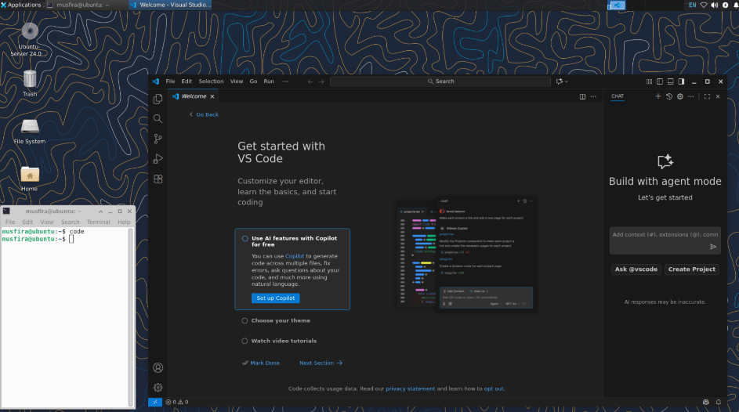

**Task 7**

Chrome Install Error Message

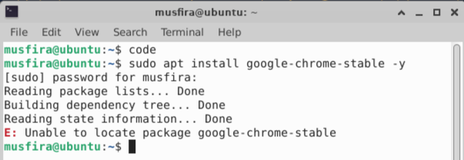

Listing apt Directory Contents

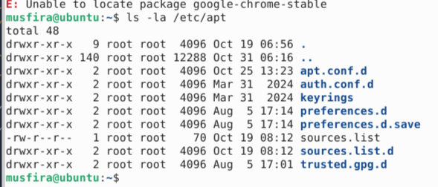

Viewing sources.list File

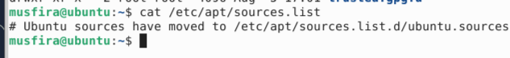

Viewing sources.list.d Directory

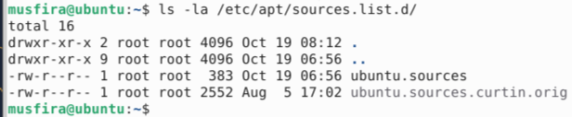

Editing ubuntu.sources to Add Chrome Stanza

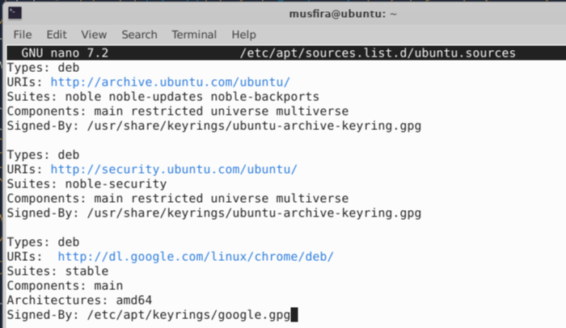

Adding Google Signing Key



Updating Packages

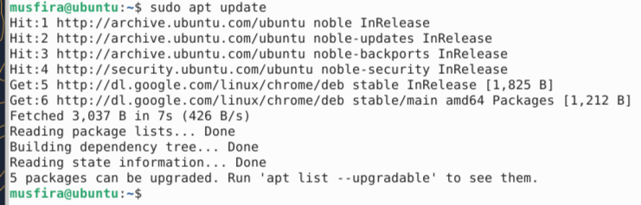

Installing Google Chrome

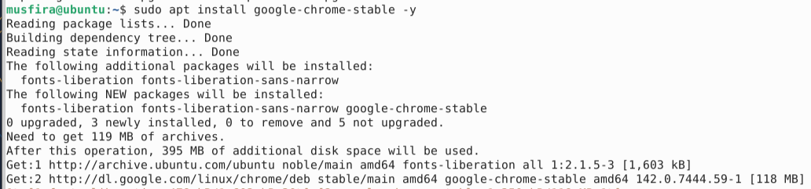

Removing Chrome Package

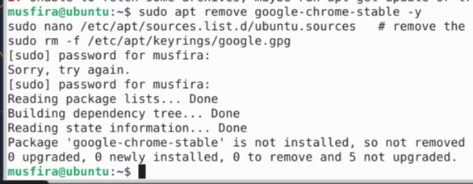

Editing File to Remove Chrome Stanza



Removing Google Key

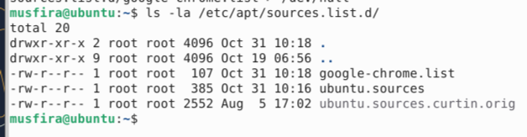

Creating google-chrome.list File



Verifying sources.list.d Directory After Creation

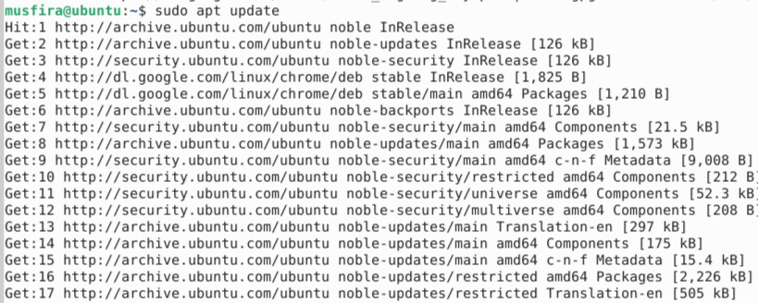

Final Chrome Installation Success

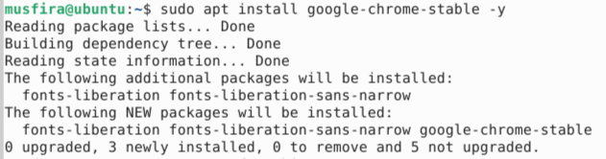

**Task 8**

Adding Audacity PPA

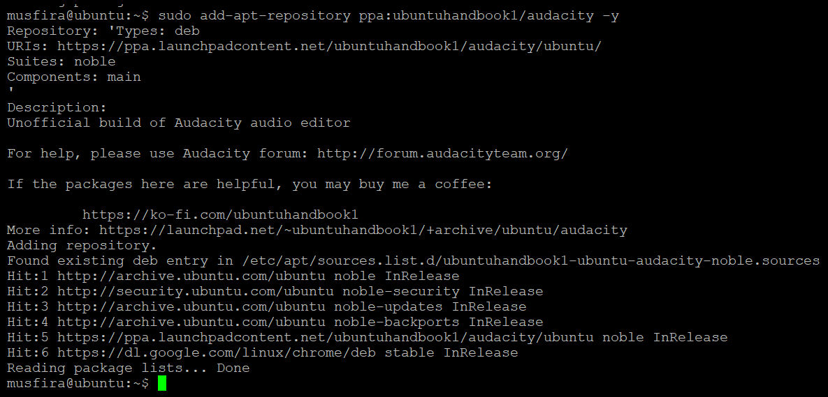

Updating Repositories for Audacity

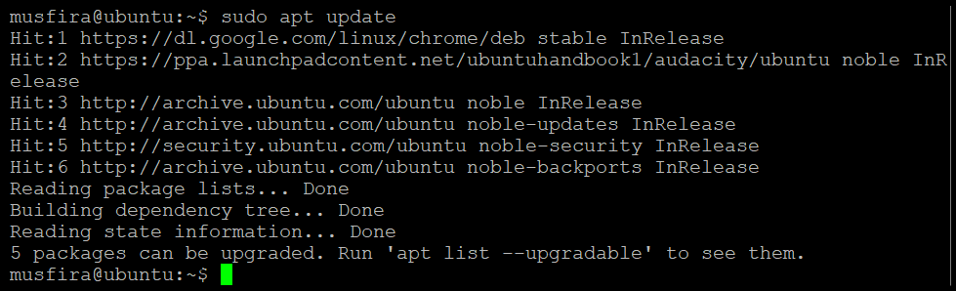

Installing Audacity

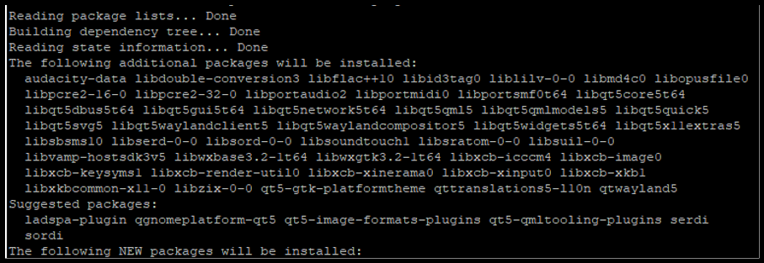

Launching or Verifying Audacity

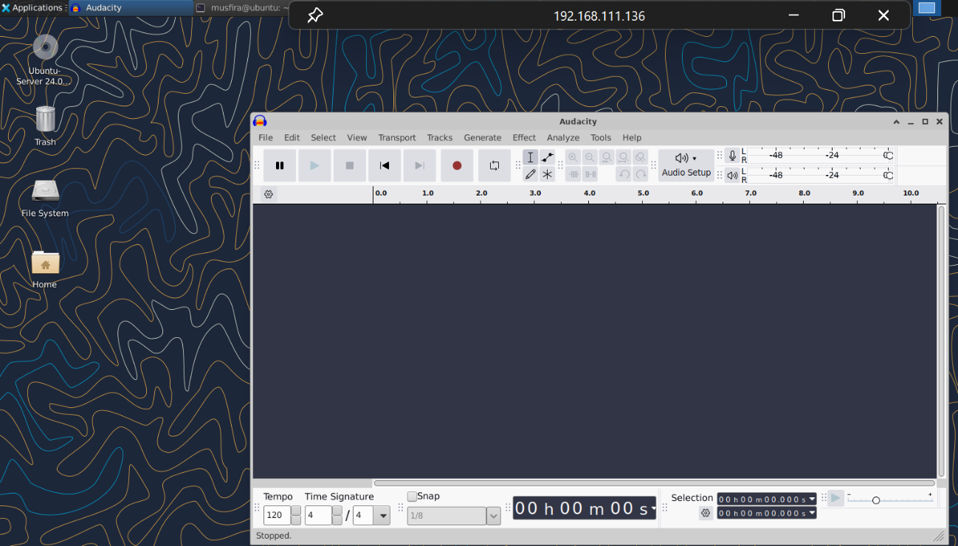

Adding OBS PPA

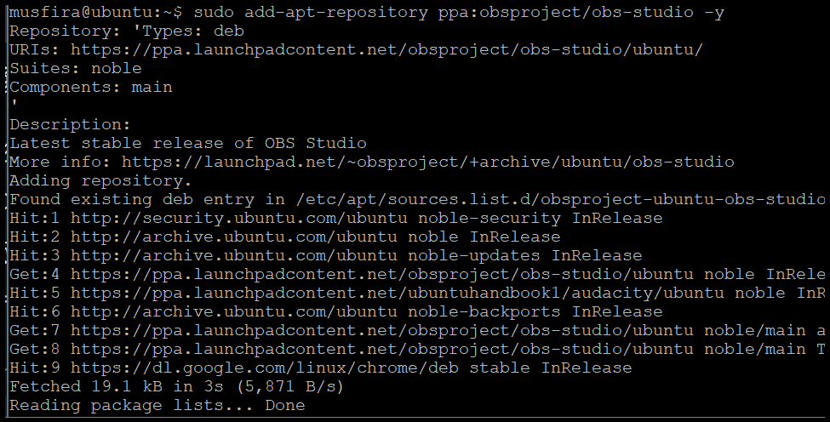

Updating Repositories for OBS

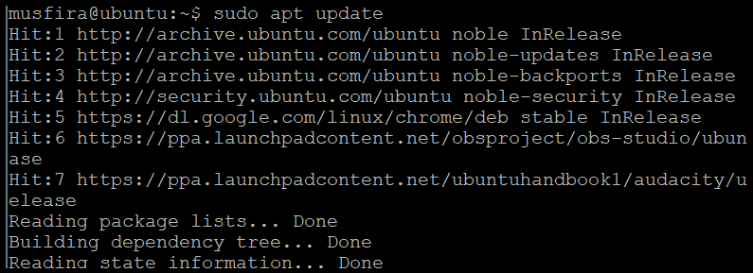

Installing OBS Studio

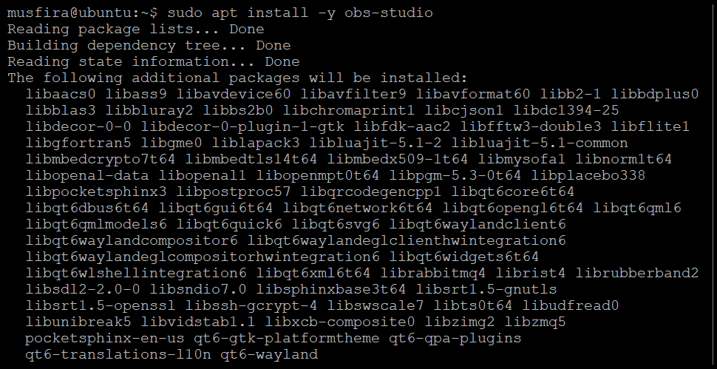

Updating again

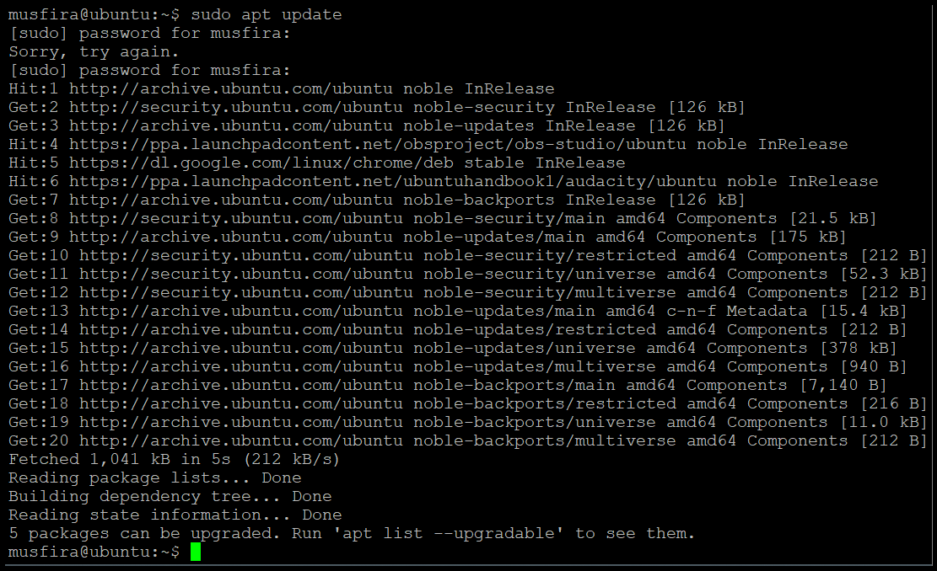

Launching or Verifying OBS Studio

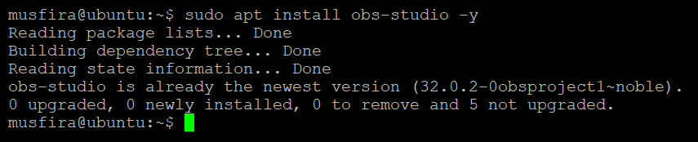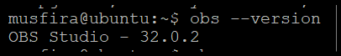

**Task 9**

Checking Vim Installation

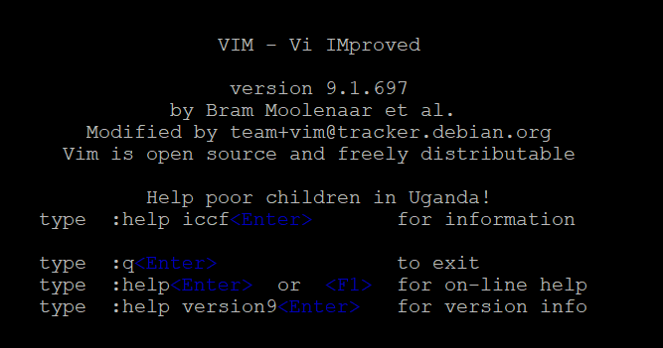

Creating Lab5 Directory and Navigating

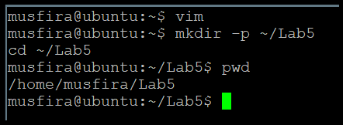

Editing k8s-sample.yaml in Vim

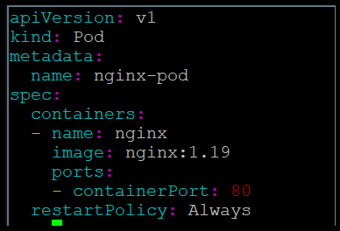

Verifying YAML File Saved

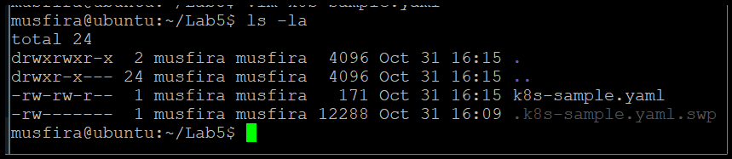

**Task 10**

YAML File After Adding Annotation

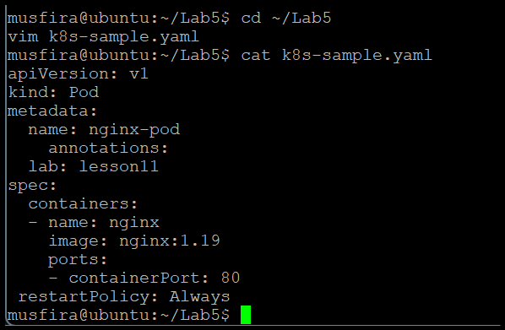

Temporary Edit in Vim (Before Discarding)

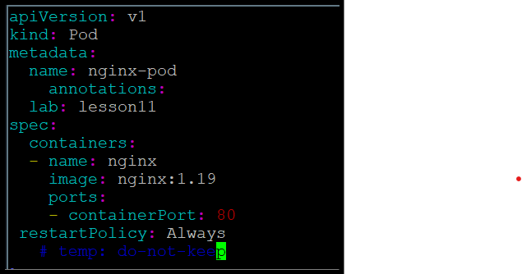

File After Discarding Temporary Changes

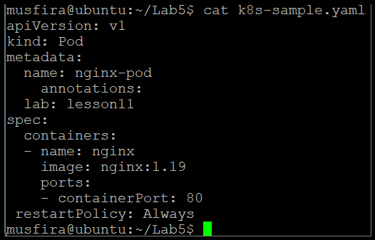

**Task 11**

Deleting a Line and Undoing

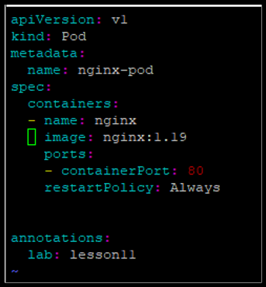

Deleting 3 Lines and Undoing

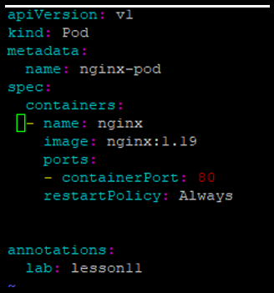

Navigating to Line 1

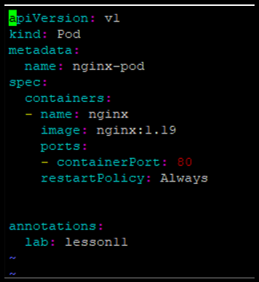

Navigation Between Line Ends

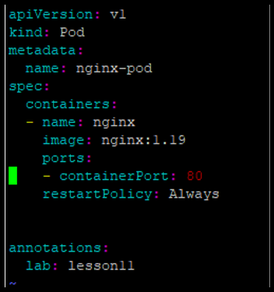

**Task 12**

Searching for “nginx”

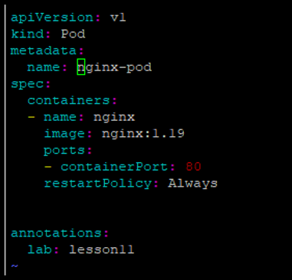

Navigating Matches with n / N

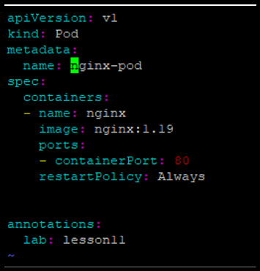

Adding Extra “nginx” Occurrences

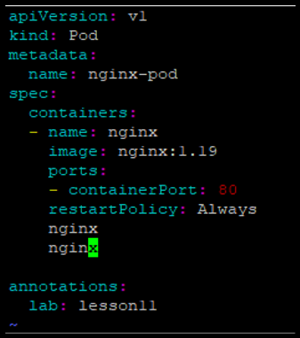

Navigating Between Matches

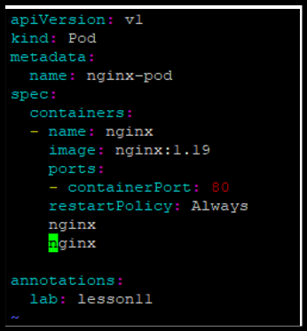

Substituting nginx → webapp

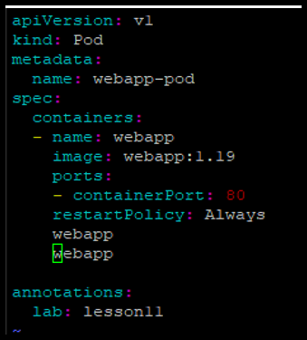

Undoing Substitution

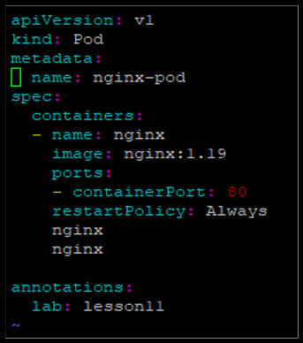

**Exam Evaluation**

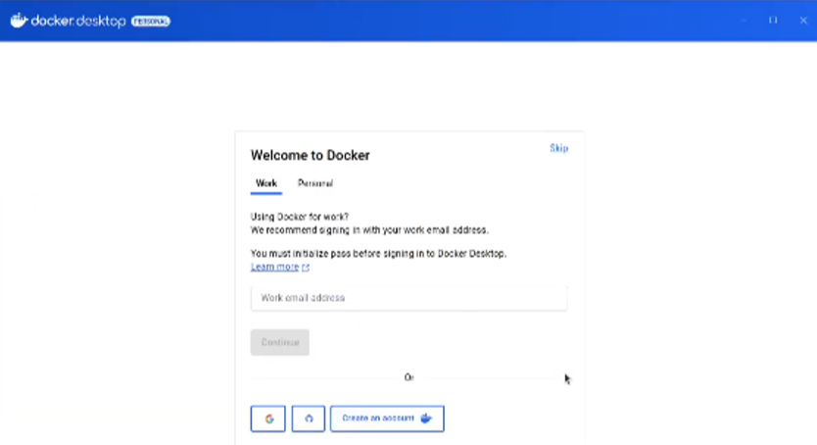Docker Desktop Successfully Installed

